**Affiliated To Tribhuvan University**

**Faculty of Humanities and Social Science**

**“APP”**

**A PROJECT REPORT**

## Submitted to:

Department of Computer Application New Summit College

***In partial fulfillment of the requirements for the Bachelor in Computer Application***

Submitted by

Anish Chauhan

July, 2024

# ABSTRACT

The Foodie heaven App is a mobile application designed to revolutionize the way users order food from various restaurants. Developed using Android Studio, the app utilizes Kotlin for frontend development and Firebase for backend services, including data storage and real-time synchronization. The primary objective of the app is to offer a seamless, efficient, and user-friendly platform that allows users to browse, select, and order meals with ease.

This project addresses common challenges in the traditional food ordering process, such as long wait times, order inaccuracies, and limited payment options. Key features include an intuitive and visually appealing user interface, real-time order tracking, and personalized meal recommendations based on user preferences and order history. Furthermore, the app provides functionalities for user profile management, saving Favorite orders, and offering feedback to improve service quality. The Foodie Heaven App aims to enhance the overall dining experience by providing convenience, efficiency, and a broad range of dining choices. Anticipated benefits include improved customer satisfaction, increased visibility for participating restaurants, and streamlined operations for food service providers. The project follows a waterfall model, allowing for continuous improvements and the integration of new features based on user feedback.

**Keyword:** *Mobile Application, Food Ordering, Android Studio, Kotlin, Firebase, Real-time Data, Waterfall Model.*

**Table of Contents**

ABSTRACT 2

1.2. Problem Statement 1

1.3.Objectives: 2

1.4. Scope and Limitation: 2

1.4.1. Scope: 2

1.4.2. Limitation: 2

1.5 Development Methodology 3

Phase I: System Analysis and Requirement Gathering 3

Phase II: Requirements Refinement and Definition 3

Phase III: Technology Selection and System Design 3

1.6. Report Organization 4

2.1 Background Study 5

2.2. Literature Review 6

FoodMandu: 6

Bhojdeal: 6

3.1.System Analysis 7

3.1.1. Requirement Analysis 7

i. Functional Requirements 7

i. Non-Functional Requirement: 8

3.1.2. Feasibility Analysis: 9

i. Technical Feasibility: 9

ii. Economical Feasibility: 9

iii. Operational Feasibility: 9

Activity Diagram 10

3.1.3. Algorithm Used 13

CHAPTER 4 14

4.1. Implementation 14

Figure 4.1. Waterfall Model 14

5.1.Conclusion 16

5.2.Outcome 16

References 17

* 1. **Introduction**

**CHAPTER 1 INTRODUCTION**

The Foodie Heaven is a modern approach to purchasing meals and groceries through digital platforms. This process involves selecting food items from a website or mobile application, which can include prepared meals ready for consumption (such as dishes from a restaurant) or raw food products (like farm-fresh vegetables or frozen meats). The primary objective of creating a Foodie Heaven system is to digitize and streamline the traditional manual method of placing orders, enhancing efficiency and accuracy in order management.

The implementation of the Foodie Heaven system has vast potential. It provides a versatile solution for restaurants, fast food chains, and home kitchens to manage customer orders effectively. This system ensures a quick, accurate, and user-friendly experience, reducing the need for physical storage space due to its digital nature. By utilizing Firebase for backend services, the system guarantees robust data security and minimizes the risk of data loss, ensuring reliability and trustworthiness.

The Foodie Heaven process starts with customers selecting their favorite restaurant through the app. They can browse the menu, pick their items, and choose between delivery or pickup. Payment options are flexible, allowing online payment via credit/debit card or cash on pickup. The app provides real-time updates on order status, food quality, preparation time, and estimated readiness for pickup or delivery. This system enhances customer convenience and transparency while helping restaurants streamline operations, reduce errors, and boost efficiency. It transforms traditional food ordering into a seamless digital experience tailored to modern consumer needs.

## Problem Statement

* In the fast-paced world we live in, people often lack the time to prepare meals at home and rely heavily on food delivery services.
* Traditional methods of ordering food can be inefficient and time-consuming, leading to frustration for both customers and food service providers.
* There is a need for a streamlined, user-friendly mobile application that allows users to order food conveniently and specify delivery times according to their schedules.

## Objectives:

The objectives of the system are as follows:

* + - To Develop a mobile application with an intuitive and easy-to-navigate interface.
    - Provide timely notifications to users about order status, delivery times, and promotional offers.
    - To Enable users to browse menus, select items, and place orders efficiently.
    - To Allow users to specify desired delivery times, ensuring that their food arrives exactly when they need it.

## Scope and Limitation:

### Scope:

This project focuses on the core functionalities of food ordering and scheduled delivery. It includes:

* User registration and login
* Browsing restaurant menus with pictures and descriptions
* Placing orders and selecting desired delivery time slots within a reasonable timeframe.
* Real-time order tracking
* Basic user reviews and restaurant ratings

### Limitation:

The limitation of the project is:

* + - * Costs associated with maintaining backup, storage, potentially higher than maintaining on- site storage alone.
* The initial version targets a limited geographical area and may include a selected list of restaurants for easier integration.
* The app might initially offer a limited range of delivery time slots to ensure smooth operations.

## 1.5 Development Methodology

In developing the "Foodie Heaven" project for our college, we have adopted the Spiral methodology, renowned for its dynamic approach emphasizing iterative development and rigorous risk management. This section outlines how the Spiral model guides the development process of our application.

### Phase I: System Analysis and Requirement Gathering

During this phase, we thoroughly review existing online food delivery systems to gather essential insights. We establish the foundational framework detailing how our system will operate and define the functionalities crucial for seamless user experience. Drawing from various online food ordering platforms, we aim to innovate and enhance user satisfaction through improved features and streamlined processes.

### Phase II: Requirements Refinement and Definition

Building upon insights from Phase I, we engage actively with our team supervisor to elicit precise system requirements. We meticulously define and validate these requirements to ensure alignment with stakeholder expectations and project goals. This phase focuses on refining the project scope and setting clear objectives for subsequent design and development stages.

### Phase III: Technology Selection and System Design

In this critical phase, we select the technologies best suited for implementing our Foodie Heaven system. Our technology selection process prioritizes scalability and futureproofing to accommodate potential growth and evolving user needs. The chosen technologies will underpin the system's architecture, supporting robust functionality and efficient performance throughout its lifecycle.

**Table 1. 1 Different Development Methodology Phases**

|  |  |
| --- | --- |
| **Phase** | **Methodology** |
| Phase 1 | Review the system |
| Phase 2 | Gathering the information and requirements |
| Phase 3 | Implementation |

## 1.6. Report Organization

The Report is organized into 5 chapters:

**Chapter 1: “Introduction” -** In this chapter we have briefly introduced our project, the problem statement, objectives and the scopes of the project.

**Chapter 2: “Background Study and Literature Review”** – In this chapter, we have described the functional, non-functional requirements, and system feasibility.

**Chapter 3: “System Design”** – In this chapter, we have introduced about the system and interface design of the application.

**Chapter 4: “Implementation and Testing”** – In this chapter we’ve illustrated the methods and tools used to implement the project.

**Chapter 5:** “Conclusion and Future Enhancement” - This is the last chapter where we have finished the project and talked about our future plans with the project

**CHAPTER 2**

**BACKGROUND STUDY AND LITERATURE REVIEW**

## 2.1 Background Study

Our analysis drew insights from several research papers pivotal to shaping the development of the Foodie Heaven project:

In one study, a wireless meal ordering system was crafted to incorporate real-time customer feedback within restaurant environments. This innovative system leverages smartphone technology in Wi-Fi settings, allowing restaurant operators to dynamically adjust menu presentations and engage directly with patrons.

Another research focused on understanding the factors influencing internet users' perceptions of online food ordering, particularly among university students in Turkey. Applying Davis' Technology Acceptance Model (TAM) alongside additional factors like Trust, Innovation, and External Influences provided a comprehensive analysis of adoption behaviors in web-based food ordering [1].

Furthermore, efforts to automate restaurant meal ordering processes were explored through the development of a mobile Android application. This system facilitates seamless wireless communication between customer devices and restaurant servers, ensuring swift updates to a central database for efficient management and timely menu adjustments.

Additionally, restaurant owners' initiatives to enhance dining experiences using ICTs such as PDAs and wireless LANs were investigated. A cost-effective touch screen-based restaurant management system, proposed as an alternative to traditional paper-based and PDA-based systems, aimed to streamline operations and improve customer service efficiency.

Lastly, a user-centered design approach was emphasized in the development of an online food ordering system, addressing critical service issues and enhancing user experience. This system simplifies order placement, provides comprehensive information to customers, manages order data effectively, and supports administrative tasks for food service operations.

## 2.2. Literature Review

The shift towards computerized systems has revolutionized management practices, particularly in the domain of online food delivery services. Unlike traditional methods reliant on physical records vulnerable to loss, modern systems leverage robust databases for secure and efficient data storage. This advancement not only ensures reliability but also enhances user-friendliness, effectively resolving challenges inherent in manual management systems. [3]

### FoodMandu:

Established in 2010 by Manohar Adhikari, FoodMandu is a pioneering online food delivery service in Nepal. It revolutionizes the dining experience by connecting customers with a diverse range of restaurants through its web and mobile platforms. Foodmandu offers a seamless ordering process, allowing users to browse menus, place orders, and track deliveries in real-time. With a commitment to customer satisfaction, Foodmandu ensures prompt and reliable delivery services, making it a preferred choice for food enthusiasts across Nepal.

### Bhojdeal:

Bhojdeal now known as Bhoj, is a popular Nepali online food ordering app focused on the Kathmandu area. It offered a convenient way for users to order food delivery from a variety of restaurants. You could browse menus with pictures of dishes, place orders, and even track your food in real-time. Bhoj currently does not offer scheduled delivery. The ordering process is simple and intuitive, allowing users to place orders swiftly and track their food delivery in real time, ensuring transparency throughout the process.

**CHAPTER 3**

**SYSTEM ANALYSIS AND DESIGN**

## System Analysis

The online food delivery software is designed to facilitate seamless ordering and delivery processes for customers and restaurant administrators. This system aims to streamline the food ordering experience by providing a user-friendly interface and efficient backend management. Restaurant administrators can manage orders, menus, and customer feedback effortlessly. The system ensures real-time updates and secure handling of customer information.

### Requirement Analysis

The term requirements determination explains the overall things that can be done within the system in simple manner. The requirements for the system can be termed as functional and non-functional requirements.

### Functional Requirements

* + The customers should be able to register and login into the system.
  + Users should be able to browse restaurants, view menus, and place orders.
  + Users can rate their experience and provide feedback.
  + The admin shall be able to update the order status.
  + The admin shall be able to edit the order status.
  + The admin shall be able to view the order status.

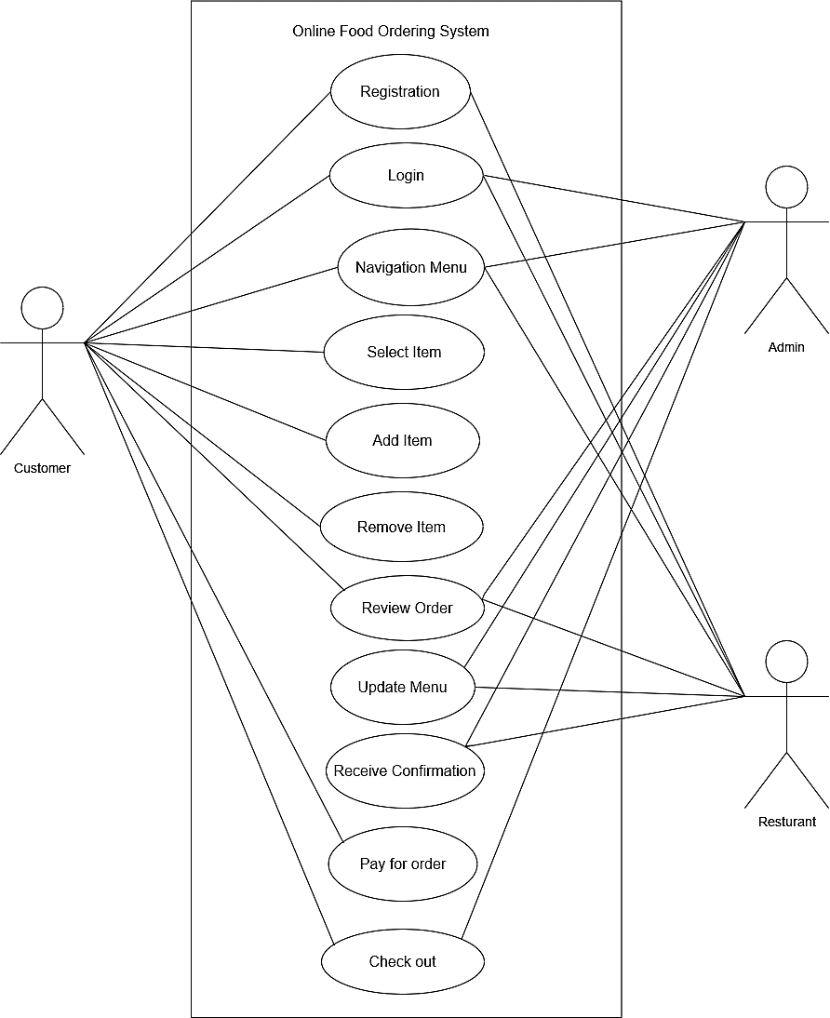

### Non-Functional Requirement:

* + Security: The system is secure which lets only authentic users.
  + Appearance: It has simple, user-friendly, and attractive to users.
  + Architecture: The architecture of this system is highly optimized and well managed.
  + Speed: It is a light application that uses minimum bandwidth and provides high-speed accessibility.

### Feasibility Analysis:

Once the problem is identified, the next step is to conduct a feasibility study, which is a high- level capsule version of the entered systems and design process. The objective is to determine whether the proposed system is feasible. The three tests of feasibility have been carried out.

### Technical Feasibility:

The proposed "Online Food Delivery" app will be developed using Java and Kotlin languages for Android development, with Firebase backend services for data storage and synchronization. Both Java and Kotlin are widely supported in the Android development community, ensuring that existing technologies can adequately support the app's development. Required hardware and software, including Android Studio and Firebase tools, are readily available and capable of supporting the app's development and implementation. Therefore, the solution is technically feasible.

### Economical Feasibility:

The "Online Food Delivery" app is being developed as part of a college project, which means there are no direct costs associated with software acquisition. Development costs are primarily related to time and effort invested by the development team. The benefits of the app include enhancing user convenience and operational efficiency. Given the project's educational context, where resources are already available, the app is economically feasible.

### Operational Feasibility:

The app is designed to be user-friendly, with a straightforward interface for both customers and restaurant administrators. Minimal training will be required for users to navigate the app effectively, ensuring operational feasibility. The system's interoperability and ease of use are expected to enhance user satisfaction and service quality, contributing to its operational feasibility.

1. **Schedule Feasibility:**

**Table 3. 1 Gantt Chart**

|  |  |  |  |  |  |  |
| --- | --- | --- | --- | --- | --- | --- |
| Working Time | 8th July | 14th June | 21st July | 25th Aug | 30th Aug | 7th Sept |
| Plan |  |  |  |  |  |  |
| System Design |  |  |  |  |  |  |
| Coding |  |  |  | |  |  |
| Implementation |  |  |  |  |  |  |
| Deploy |  |  |  |  |  |  |
| Documentation |  | | | | | |

**3.1.3 Process Modeling**

While developing a system in order to ensure that all requirements have been met by the system and the users are satisfied with how the system is being implemented, we’ve done process modeling. This modeling is supposed to help the system is created in the most logical manner and will be able to be used for a long time.

### Activity Diagram

**Figure 3. 1 Admin workflow Process**

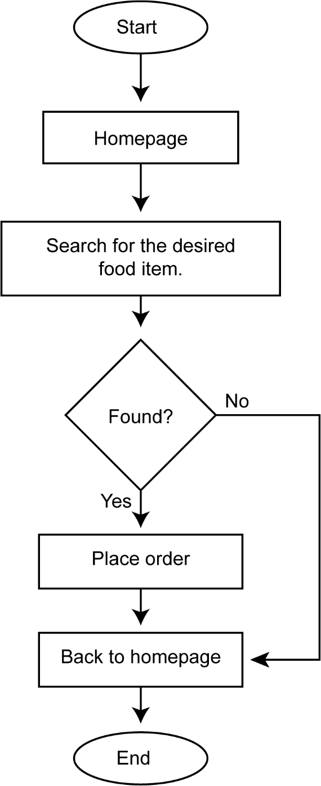Initially to visit the food categories or food menu, users don’t need to login/register an account. After checking out the categories and menu items, if the user finds his/her desired menu and if they want to order that particular item, they can go to the order page. During placing any order, the customer needs to provide his/her required information mentioned the order section.

Fig: Customer Workflow Process

**E-R Diagram:**

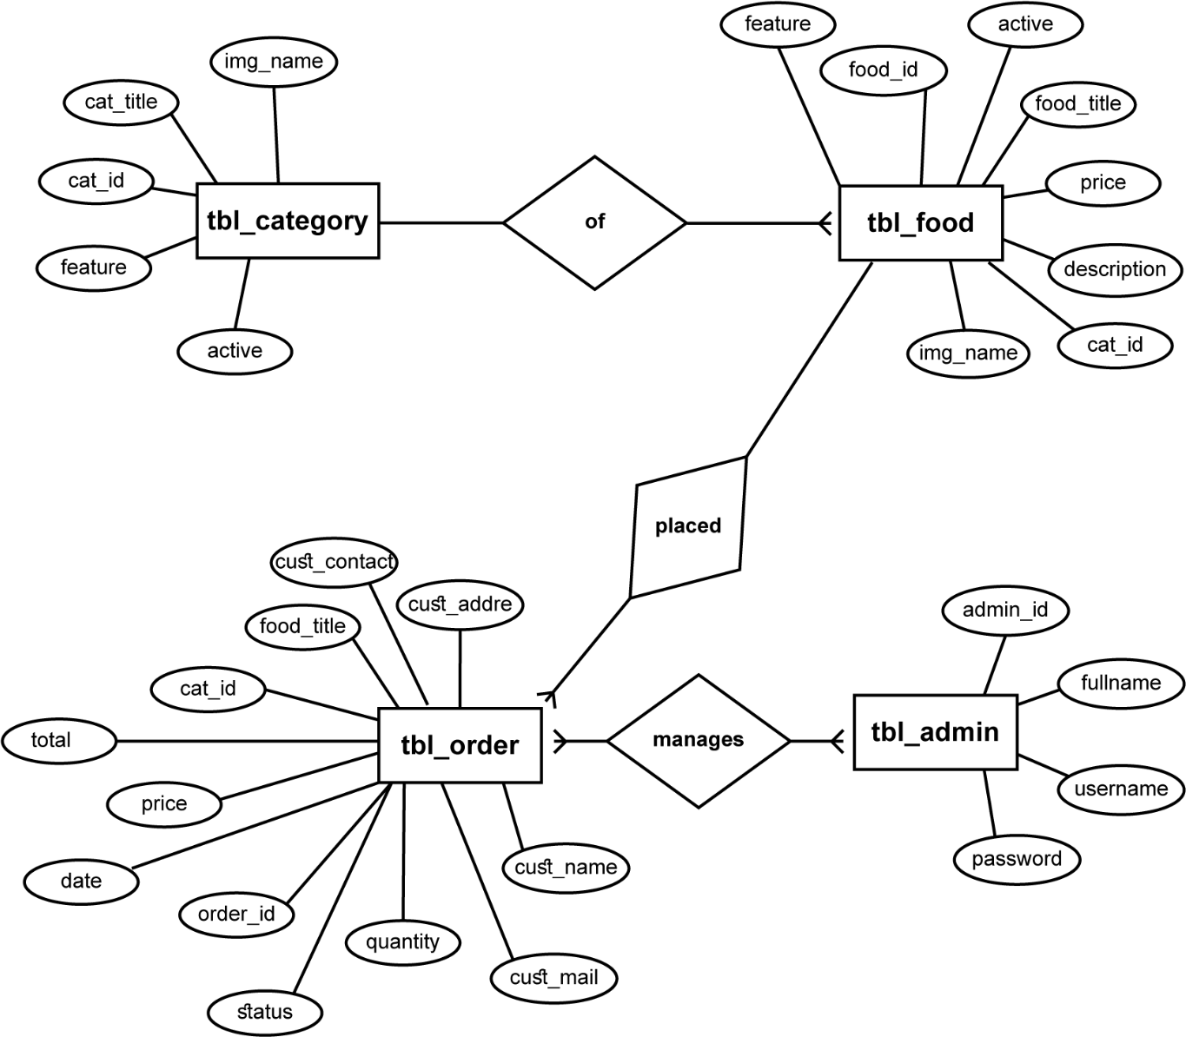

**Figure 3. 2: Deployment Diagram**

### Algorithm Used

**Dijkstra's Algorithm**

Dijkstra's Algorithm is used to find the shortest path between nodes in a graph, which makes it particularly useful in a food ordering app for optimizing delivery routes. Here’s why Dijkstra's Algorithm is suitable:

1. **Efficient Route Calculation:**

* It finds the shortest path from the restaurant to the customer's location, ensuring timely deliveries.
* Optimizes delivery times, which improves customer satisfaction and reduces delivery costs.

1. **Real-Time Traffic Data Integration:**

* The algorithm can be integrated with real-time traffic data, helping to avoid congested routes.
* Ensures the delivery person follows the most efficient route available at any given time.

1. **Scalability:**

* Dijkstra's Algorithm is scalable and can handle a large number of delivery points and routes.
* It can efficiently manage multiple orders and deliveries simultaneously.

1. **Reliability:**

* Provides reliable and predictable delivery times, which enhances the overall user experience.
* Helps in managing the delivery fleet effectively by providing optimized routes.

# CHAPTER 4

**IMPLEMENTATION AND TESTING**

## Implementation

For this project we have chosen the Waterfall model. It is a traditional and widely used methodology for software development. It is a linear and sequential approach, where each phase of the development process must be completed before the next phase begins. Using the in the project provides a clear, structured, and manageable approach to software development. With well-defined phases, thorough documentation, and a focus on stable requirements, the Waterfall Model ensures that each aspect of the project is meticulously planned and executed, leading to a high-quality and reliable final product

### Figure 4. 1 Waterfall Model

* + 1. **Tools Used**
       - **Android Studio:** It provides the development environment for building Android apps.
       - **Kotlin:** Kotlin are programming languages used for Android app development.
       - **Firebase:** Firebase is used for backend services such as real-time databases, authentication, and analytics in Android apps.
       - **Draw.io:** Draw.io is a free diagram software that helps in making UML diagram such as like Use Case, Class Diagram, Sequence Diagram and Activity Diagram in our project.

**CHAPTER 5 CONCLUSION AND FUTURE WORK**

## Conclusion

To conclusion, the development of our Foodie Heaven app using Android Studio, Kotlin, and Firebase represents a significant advancement in modernizing the food ordering experience. The project was meticulously designed to meet user specifications and address shortcomings identified in traditional food ordering systems. It embodies a commitment to enhancing convenience, transparency, and efficiency for both customers and restaurant administrators. It has the potential to disrupt the food delivery market by addressing the need for precise delivery timing. This app not only streamlines the ordering process but also integrates robust features for real-time updates, secure transactions, and personalized user interactions, thereby improving overall service quality in the food delivery sector.

## Outcome

1. Creation of a seamless platform for managing food orders and deliveries.
2. Implementation of an intuitive and user-friendly interface for enhanced user experience.

# References

|  |  |
| --- | --- |
| [1] | K. Acharya, "Online Food Ordering System," ResearchGate, kathmandu, 2022. |
| [2] | M. A. J. &. B. T. Keeble, "Investigating experiences of frequent online food delivery service use: a qualitative study in UK adults," 16 07 2022. |
| [3] | K. Acharya, "Online Food Ordering System Project Report," p. 1, 08 05 2024. |